Lab 1 Initial Plan for Soil Collection
Friday, August 11, 2017
7:33 PM

Experiment 1: Devise a method to transfer microbes from a soil sample to a medium in the lab.

- Background:

Isolating bacteria from soil is an important first step in many microbiology experiments. Once they are isolated, bacteria can be further analyzed to determine things, such as their species and their function in the soil environment. Even a tiny amount of soil can contain millions of bacteria, which makes it necessary to dilute a soil sample before isolating bacteria from the sample
- Objective of the experiment:
To isolate and count the microorganisms found in a sample of soil by the dilution method using aseptic techniques
- Hypothesis and rationale:
to see grow in both gram positive and negative
- Isolation method used:
1.Mark the dilutions on the vials (10-3 , 10-4 , 10-5 , 10-6 ) and Petri plates (10-4 , 10-5 , 10-6 ).
2.Add the 0.5g soil to the Erlenmeyer flask containing 50ml of agar (this is the 10-2 dilution).
3.Shake well for at least one minute.
4.Using a sterile pipette, take 0.5ml and place it in a vial containing 4.5ml of 0.1% agar. (this is the 10-3 dilution).
5.Shake well for at least one minute.
6.Repeat steps 4 and 5 for the three other dilutions (10-4 , 10-5 , 10-6 ).
7.Starting with the weakest dilution (10-6 ), pipette 1ml onto each of 2 Petri plates containing PDA. Spread over the entire surface using the sterile glass stirring rod. (The 10-6 dilution first.) Follow the same steps for the 10-5 and 10-4 dilutions.
8.Seal the Petri plates with the Parafilm.
9.Incubate the Petri plates at room temperature.
- Observations:
The Gram positive unknown was identified to be Bacillus subtilis. The instructor verified this to be correct.
The Gram negative unknown was identified to be Pseudomonas aeruginosa.
- Evaluation and conclusions:
No difficult problems occurred with the identification of B. subtilis. The only slight issue was that B. subtilis grew extremely quickly and overgrowth was a common problem. For example, a nutrient agar stock plate for B. subtilis was inoculated almost daily to ensure the cultures used for each of the identification tests were young.

Lab 2 Soil Sample Location
Friday, August 11, 2017
7:37 PM

Experiment #2 Find a local soil environment you wish to sample

Background: forest fro near by park were it looks like no one real go that deep in it

Objective: collecting solid

Criteria for picking soil sample:

plenty of soil to pick from but I got what was look more moister that dray
Vegetation present
Any sign of odd features in spot of vegetation
eg. Different plants, fungal infection, decay, etc.
soil that has more of a sand, silt texture than soil

Soil sample site:
humidity and dark environment
sample was looking very simple no thing really that unique about except that it was picked from under a dead tree that it seems it was fallen for a long time

Hypothesis and rationale:
Since bacteria live in habitats like soil, water, hot spring, radioactive waste, and more other.
There will definitely with be bacteria in my sample

Technique used for collecting your soil sample:
By directly to the tube
10 gram of soil at 2 pm afternoon
Monday Sept 4
o 14:21 after sleeping on it last night, going out to collect my sample from the fields trail behind the park next to my yhome. Specifically the Fallen tree

Lab 3 Method to Isolate Single Colonies

Experiment 3: Find a method to isolate single colonies of bacteria from your soil sample.

- Background:
There is so much bacteria in a raw sample of soil, that It would be impossible to count the amount of colonies. A Method needs to be devised to single out colonies so that counting them would be an easier task

- Objective:
To Find a method that is best suited to isolate single colonies of bacteria from my soil sample effectively.

- Hypothesis and rationale:
Using the serial dilution method used in the protocol handbook, I will be able to isolate some single colonies from my raw soil sample which I will calculate cell denisty. Serial dilution is a method used to dilute a raw sample to 1:10 dilution which reduces the number of cells per volume making it easier to count cell density.

- Procedure for obtaining single colonies on plate:
Plates used: Potato Dextrose Agar, Luria Bertani
1. Obtain 4 1.5 ml microcentrifuge tubes and plates DON’T FORGET TO LABEL! USE TAPE!
2. Weigh 1g of soil sample
3. Transfer to a 15ml conical tube or test tube (make sure is large enough)
4. Add 9ml of water to soil (ask professor if tap or DI water before beginning to pour) 5. Place tube in sonic bath or vortex 30-60sec
6. Add 900 uL (.9 ml) to each microtube
7. Remove 100ul of INITIAL concoction (0.1ml on disposable pipette is the end of narrow opening) and add to 10^-1, mix by vortex 30-60 ASK PROFESSOR ABOUT MIXING TECHNIQUE
8. REPEAT! Remove 100ul from 10^-1 add to 10^-2, mix by vortex 30-60
9. ^^^REPEAT TILL FINISHED^^^
10. With each dilution, remove 100uL (.1ml) from each. Add to each labeled plate. Make sure to spread concoction. ASK PROFESSOR ABOUT SPREAD PLATE TECHNIQUE. GLASS BEADS?
11. Note volume and dilutions plated (note on one note, notebook and on plates) 12. Use formula (see notes) to calculate CFU in soil sample Ask how to dispose of end of experiment

- Draw a schematic of the procedure used:

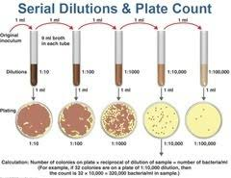

- Data and observations:
After plating and incubation period of 2-3 days, the PDA plates resulted in too low of count (not between the 30-300 range) in CFUs to be counted. On the other hand the Luria Bertani plates had enough colonies to be countable and to also be able to have CFU/g calculations preformed. Colony count for 10^-3 Luria Bertani is ~136 with a 1.36X10^6 CFU/g count. Colony count for 10^-4 Luria Bertani is 17 with a 1.7X10^6 CFU/g count. Colony count for 10^-5 Luria Bertani is 14 with a 1.4X10^7 CFU/g count. Colony count for 10^-6 was too low to count and calculate CFU/g.

- Interpretations and conclusions:
In conclusion, Adding the raw sample of soil to a Petri dish would not have been favorable for the overall experiment due to the overwhelming amount of bacteria in a raw sample. To reduce te number of bacteria to a countable a serial dilution was needed. After dilution, plating and incubation for 2-3 days PDA plates resulted in a very little amount of CFU. While in the LB plates, CFU was a lot more abundant. Due to the lack of amount of culture grown on the both plates, a mistake could have occurred. The errors I could see happening with my soil sample and why it did not grow is because: PDA might not have been the best media to grow my culture on, The depth where I collected the sample might have been too shallow and Horizon A was not reached.

Lab 4 Optimizing Conditions
Friday, August 11, 2017
10:57 PM
Choose your own media and culture conditions.

- Background:
The type of culture media determines the type of bacteria that can grow. These are determined by specific characteristics of the media such as types of nutrients present, the osmotic pressure, the pH, blood etc. The individual chemical ingredient used to make a culture media vary allowing the media to select for or against the microbe

- Objective:
To select the most appropriate media

- Medium of choice and rationale:
In these case, I chose to use a nutrient agar plate. Due to its complexity, the media contains the nutrients that are needed for growth of most soil microbes

- Culture condition of choices:

Temperature: 37-degree centigrade. This is the optimum temp

Oxygen level: for this, I will use the ambient air oxygen concentration as it corresponds to the soil natural level

Other:
Water
Nutrients. This includes carbon, nitrogen, phosphor or sulfur.
pH many bacteria grow well at near neutral PH i.e. 6.5-7.5
Amount of light
Salt level less than 2%

- Hypothesis and rationale:
Nutrient media is able to support the growth of all soil microbes. This is because, it is assumed that it contains all the nutrient requirements needed to cultivate soil microbes in the lab
- Experimental design and techniques used:

The nutrient agar is prepared following the guidelines to provide by the manufacturer. One the soli sample has been concentrated and then diluted serially, it is then inoculated onto the culture media. The pour plate technique should be used initially to inoculate the microbes. This is then incubated under appropriate conditions for 24 hrs. Then revisited.
There will be the formation of different culture media. To produce pure culture, we will use the streaking method to select unique colonist before inoculation in new culture media i.e.
1-Sterilize the inoculation loop using a Bunsen burner.
2-Pick an isolated culture from the agar plate and gently spread it over the first quadrant using the parallel streak method
3-Streak the inoculating loop immediately gently over a quarter of the plate using the back and forth method
4-Flame loop again then allow it cool. From the edge area 1 that you had streaked, extend the streak to second quadrant (our area 2). Flame the loop again and allow it cool. From area 2, extend the streak to the 3 rd. a quarter of plate (area 3)
5-Flame the loop again and allow it cool. From area 3. Extend it to the fourth quarter.
6-Flame loop again.
7-Allow culture media to grow by incubation at 37-degree centigrade for 24 hrs.
8-If there is more than one colony, streak again in separate media to obtain a pure culture.

- Control and treatments:
The control for this experiment will require growing the microbe under a low oxygen and high carbon dioxide environment or an environment deprived off some nutrients. The nutrient agar can also be treated with some chemicals to see whether they inhibit the growth of the microbes

- Data and observations:
There will be the formation of bacterial colonies on the culture media. The colonies will be of different general appearance signifying the growth of different species or line of bacteria. To grow a pure culture, we will have to streak organisms from each unique culture onto a new media

Interpretations and conclusions:

Lab 5 Antibiotic Production
Isolate unique colonies to test for antibiotic production.
- Background:
In microbiology, streaking is a technique used to isolate a pure strain from a single species of microorganism, often bacteria. Samples can then be taken from the resulting colonies and a microbiological culture can be grown on a new plate so that the organism can be identified, studied, or tested. The modern streak plate method has progressed from the efforts of Robert Koch and other microbiologists to obtain microbiological cultures of bacteria in order to study them. The dilution or isolation by streaking method was first developed by Loeffler and Gaffky in Koch's laboratory, which involves the dilution of bacteria by systematically streaking them over the exterior of the agar in a petri dish to obtain isolated colonies which will then grow into quantity of cells, or isolated colonies. If the agar surface grows microorganisms which are all genetically same, the culture is then considered as a microbiological culture.
- Objective:
to isolate antibiotic producing microorganisms from soil that may be antibiotic producera
- Hypothesis and rationale:

- Protocol:
Bring a specimen of soil from any location. 2. Weigh out 1 gram of soil. 3. Obtain 4 plates of the appropriate agar medium (depending on whether your group is searching for bacteria or fungi). Label these plates 1/103 through 1/106 . 4. Set up a series of 1/10 dilutions: a. Place 6 test tubes into a rack and fill each with 9ml of 0.9% NaCl solution. b. Place the gram of soil into the first tube with saline and SHAKE WELL. c. Let the soil particles settle after shaking and then transfer 1ml of the solution into tube 2. This is your 1/10 dilution. d. Repeat the above step for tubes 2-6, changing 1 ml pipets between each transfer. Be sure TO SHAKE EACH TUBE WELL before transferring into the next tube. These tubes will be dilutions of 1/102 , 1/103 , 1/104 , 1/105 ,and 1/106 . 5. Place 0.1ml of the 1/103 dilution onto the top of the appropriate agar. Place the spreader into the alcohol solution and then stick it into the flame to catch it on fire. DO NOT HOLD THE SPREADER IN THE FLAME. When the fire is out, you have a sterile spreader. Place the spreader on the agar with the 0.1ml sample and spread the sample all over the agar medium. 6. Your plates will be made from the 1/103 through 1/106 dilutions. 7. Incubate the plates at 30C until the next lab session. If you do not have sufficient colony numbers, re-incubate the plates and carry on the exercise at next period after.

- Results:
Number of isolates picked:
5 from NA
Characteristics of isolates:
1 white 2 yellow 1clear 1 clear grey
Irregular, flat, curled, smooth, rough, moist,
- Interpretations and conclusions:
Potent antibiotics from these actinomycetes could contribute a lot to fight against antibiotic resistant pathogens. Selected isolates have been shown strong antimicrobial activity against resistant pathogens. Further purification, structural elucidation and characterization are recommended to know the quality, novelty and commercial value of these antibiotics.

Lab 6 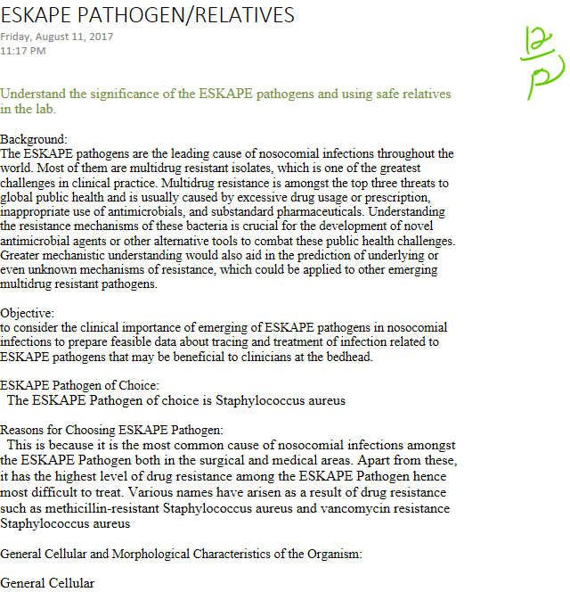
It is a gram-positive coccus in clusters
Nonmotile
Encapsulated
Nonspore forming
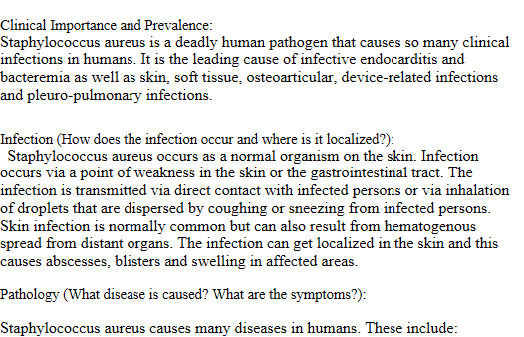
Bacteremia--- fever, septic shock
Infective endocarditis—persistent SAB and persistent fever.
Skin and soft tissue infections- Impetigo, necrotizing fasciitis, SSCS,
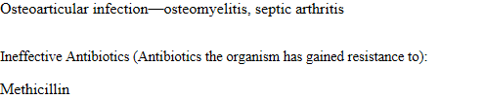
Penicillin G
Penicillin V
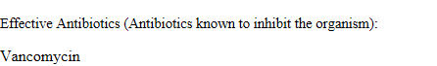
Floxacillin (Floxapen)

Lab 7 Screening Method
Friday, August 11, 2017
11:20 PM
Experiment 7: Design a method to screen for antibiotic producers

- Background:

Naturally soil is rich in microorganisms capable of producing antibiotic synthesis.
antibiotics include a chemically heterogeneous group of small organic molecules of microbial origin that, at low concentrations that are deleterious to the growth or metabolic activities of other microorganisms.

- Objective:

to determine an antibiotic that can fight the pathogens from the soil

- Hypothesis and rationale:

There should be rapid detection or estimation of groups of (indicator) organisms, pathogenic micro-organisms, and bacterial.

- Experimental design and protocols used:
1.obtain medium for ESKAPE to grow
- Label plate for with respective medium, ESKAPE, and master plate
3.use liquid culture of ESKAPE and transfer a 150 ul of the ESKAPE INTO medium plate
4.spread ESKAPE IN the plate
5.pick I isolate from master plate
6.put plate in top of grid and plate isolates arranged in same as master plate
7.incubate

- Controls and treatments:

1.B. subtillus gram +
2. Eewinia caratova gram -

- Data and observations:

5 isolates have been shown antagonistic activity during primary screening. Inhibition zones obtained from crude extracts showed significance differences.

5 0f the 9 isolates plated showed a resistance. # 5, 18, 12 showed antibiotic resistance and # 12, 18show resistance for the both grams ( + and - )

- Interpretations and conclusions:

isolation and screening of soil from such areas in optimum condition may contribute the discovery of new antibiotics.
Initial ID of Antibiotic-Producing Isolate-Data gathering
Experiment 8: Conduct initial identification of your antibiotic-producing isolate

Background:
In recent years new bacterial pathogens are being found to be emerging with resistance to almost all antibiotics. It has become essential to develop novel antibiotics to overcome forth coming challenge of treating infectious diseases

Objective:

A trial to find out a new antimicrobial agent producing bacteria from soil samples screened for their antimicrobial activity against the pathogenic bacteria

Results:

Isolate name | Tentative genus | Percent ID to closest relative | Size of query sequence (nt) | Date of BLAST | Gram stain | Cell shape | Produce antibiotics? | Other
#5 |  |  |  |  | + | rod | yes
#8 |  |  |  |  | _ | rod | yes
Based on morphological and/or molecular data, indicate the number of distinct antibiotic producers:

Literature search:

• Morphology: Do your observations match information in the literature?

yes

• Antibiotic production: Do your observations match information in the literature?

yes

Interpretations and conclusions:

mean there could be a producing of antibiotics from the isolated data

lab 9
Experiment 9: Test your isolate’s organic extract for antibiotic activity

- Background:

Metabolic activity in Microorganisms are divided in to primary and secondary metabolism. While primary metabolism is charged with storing energy, releasing energy and building macromolecules, secondary metabolism creates molecules usually not essential to life, but are unique to that organism. This is where antibiotics reside and how they are formed. To isolate these metabolites from other metabolites present in the agar they are grown in, steps are taken to separate the metabolite via its
chemical and physical compounds. Using polarity to you advantage can help separate a specific compound for extraction.

- Objective:

To Isolate and extract organic metabolites via use of Ethyl Acetate or methanol
Hypothesis and rationale:
Utilizing Ethyl Acetate, we hope to polarize and separate the metabolites produced by our isolates from the agar to be able to determine physical and chemical properties.

- Experimental design and protocols used:

Protocol used: Analyzing Organic Extracts for Antibiotic Production
- Solvents used:
Ethyl Acetate

Solvent pros and cons:

Controls and treatments:

- Data and observations:

#5 bottle initial weight 15.1g = .0151kg #5 bottle final w/ ethyl acetate weight 22.5g = .0225kg
#8 bottle initial weight 14.9g = .0149kg #8 bottle final w/ ethyl acetate weight 28.9g = .0289kg
#58 Final bottle weight evaporated 14.992 = .014992kg

